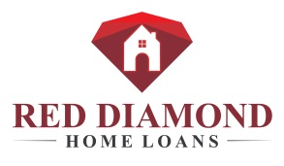

February 19, 2018

Mr. Ralph Goodbuilder
President
Quality Homes, Inc.
9999 Construction Way
Dallas, TX 99999

Dear Mr. Goodbuilder:

Are you getting all that you should from your mortgage relationships? If not, why not join other home builders like you in establishing a relationship with Red Diamond Home Loans, LLC (“Red Diamond”), and in the process add some new-found service revenue to your bottom line. Our chief objective is to help you close more homes. To that end, we will work with you to better coordinate the financing and home buying processes, and, as a result, produce smoother closings and happier customers. Additionally, we can offer you the opportunity to market Red Diamond on our behalf for a flat monthly fee. So, why not be a resource to your customers and receive added value for your efforts with a mortgage relationship with Red Diamond? Have I stirred your curiosity? Then its time we talk.

Red Diamond is a mortgage company looking for business associates like you. We are committed to bringing selected home builders high-value mortgage opportunities through our lender relationship and marketing agreement. Red Diamond brings you a proven mortgage process, a seasoned team of mortgage professionals, and a history of success in serving home builders like you. And, we offer you a broad array of competitive, residential loan programs to meet your homebuyers’ financing needs.

Red Diamond would welcome an opportunity to further describe our lender program and marketing agreement at your convenience. Feel free to call me at 999-999-9999 with questions or to register your interest. I will be following up with you in a few days to obtain your feedback and discuss your added revenue potential, with no obligation. I look forward to speaking with you.

Respectfully,

Sarah Goodbranch
Branch Manager

