How to Install a Wordpress Site When It Doesn’t Show Up on Bluehost
- Type the url of the new domain into the search bar in Google (ex. http://rdhloans.com/yournewsite/) and press enter.
- It will ask what language you wish to have your site in. Choose English.
- This screen will pop up and have you fill it in. It is easiest to remember if you make the username and email mikenporter@gmail.com, and the password Outlook5$$
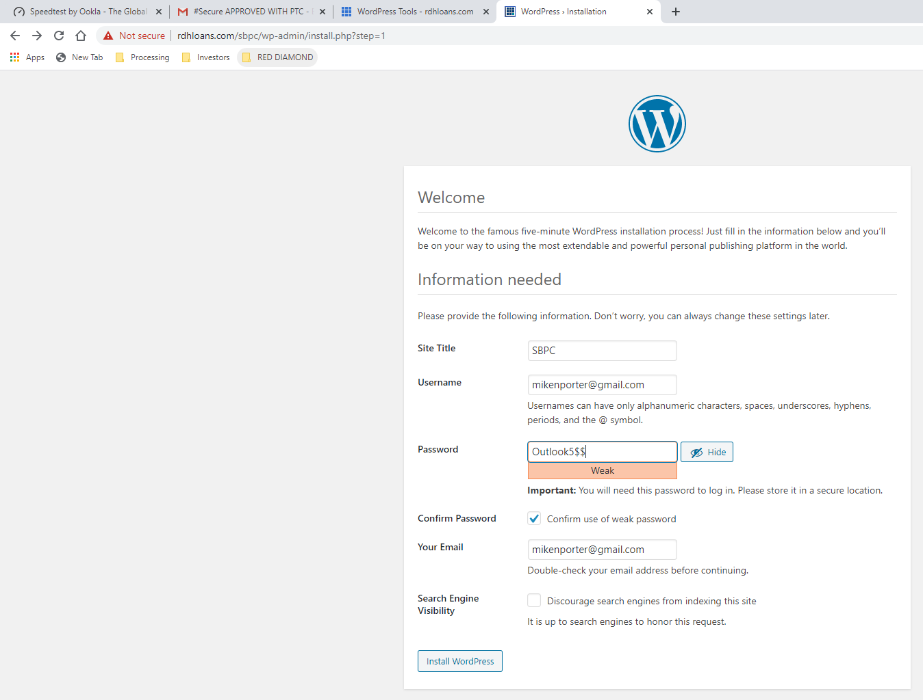

- It will then let you login onto the site and edit it. To secure the site, you must log into Bluehost and find it on Wordpress Tools. From there, click security on the left side and press the switch that makes it secure. It may not show up on Wordpress Tools immediately after you install the site, but it will eventually. Until then, you can still edit it by typing in the URL on google search and logging in with the username and password you made in step 3.

