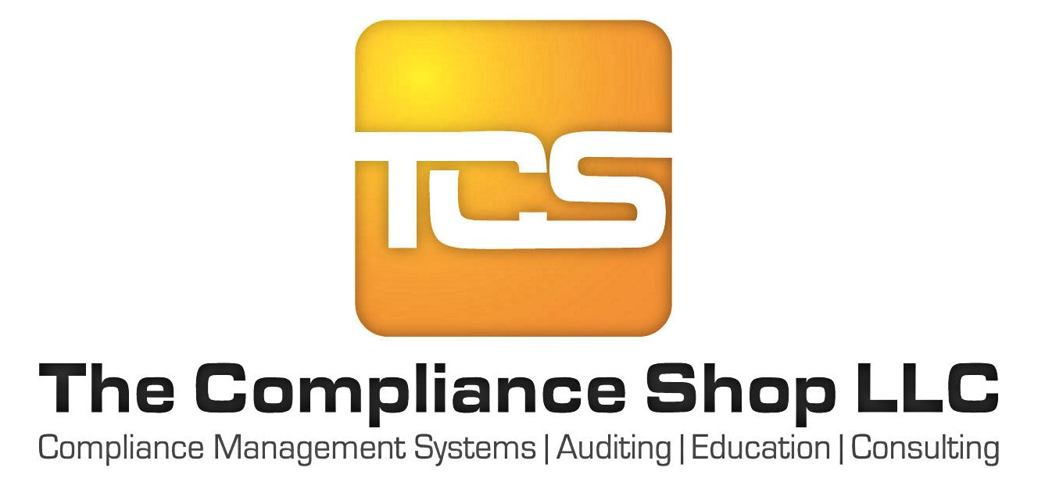

Social Media Review

All employees are required to have all professional/ business websites reviewed for compliance, and their addresses on file with the QC Officer. Please provide the URL’s/web addresses to any of the following accounts you may have (if you have more social media platforms than spaces below please use a 2nd copy of this form):

Employee:

Date:

Approved Social Media Platforms:

Facebook:

You Tube:

LinkedIn:

Google +:

Zillow:

Other:

Other:

Non-Approved Social Media Platforms:
- Instagram*
- SnapChat*
- Craig’s List
- Twitter *
- Pinterest*

*Due to the limited number of characters, it is not possible to meet the requirements when soliciting for business. If you do happen to have any of these social media platforms, please still provide us with the URL.

The QC Officer, along with management, will be responsible for monitoring these websites for compliance, and to ensure the content posted has been approved. Any business accounts discovered to contain adult language, hate speech, inappropriate content, malicious links or other risky content or activity will be grounds for immediate termination.

