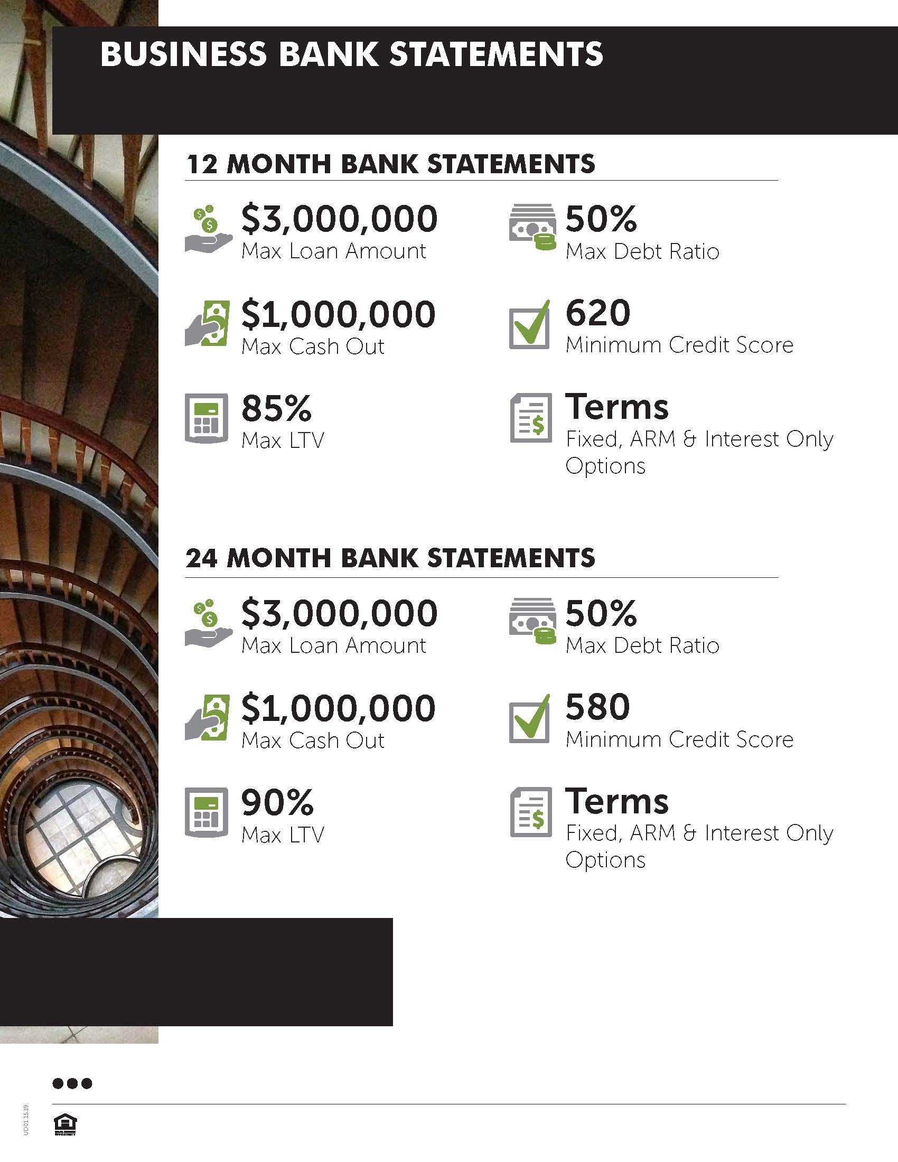

**Name**

Title

Number

Email

Insert seller disclaimer here…